PROJECT DOCUMENTATION / DATA FLOW DIAGRAM & USER STORIES

Data Flow Diagram & User Stories
Data movement and backlog-ready user stories
DATE  07 October 2026 | STUDENT NAME  Gangadevi.R | PROJECT  Incident Life Cycle Automation

Data Flow Diagram
The diagram below shows the core flow of incident data between users, automation processes and the audit-ready incident store.
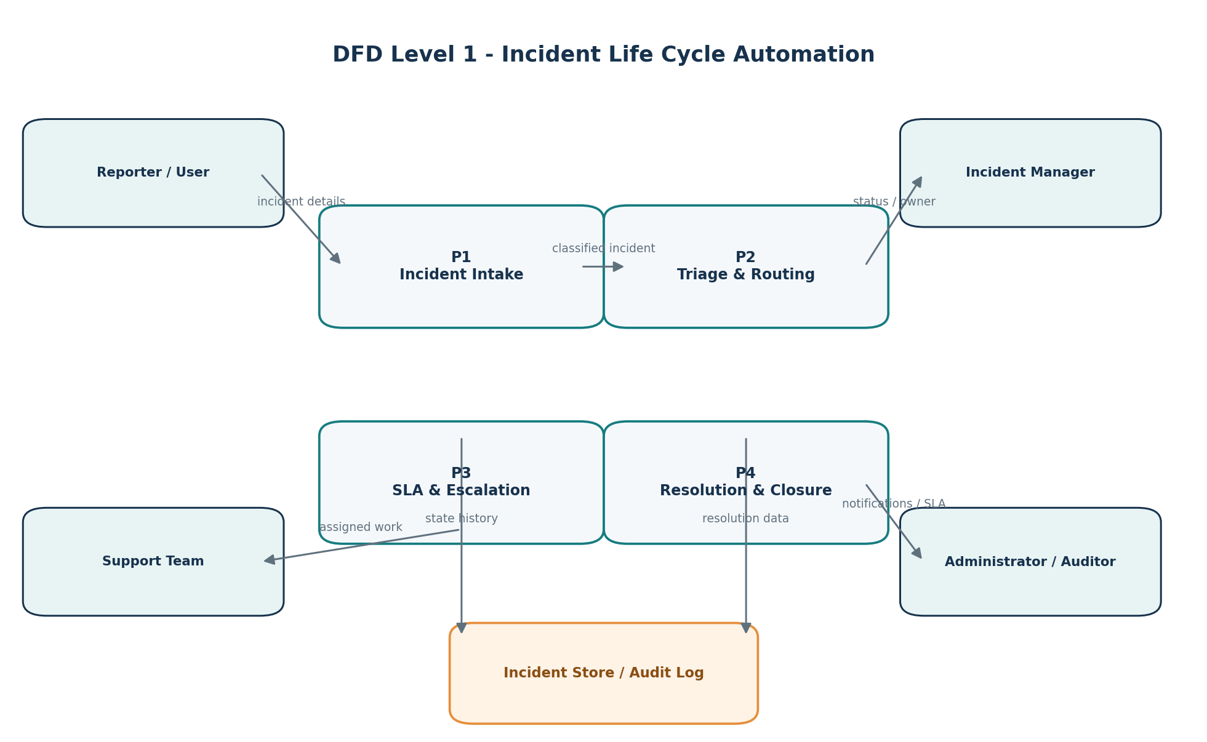

User Stories
User Type | Epic | Story No. | User Story / Task | Acceptance Criteria | Priority | Release
Reporter / End User | Incident Intake | US-01 | As a reporter, I can submit an incident with the required details so that it can enter the lifecycle. | A unique incident ID is created and the incident is visible in New / Logged state. | High | Sprint 1
Reporter / End User | Status Tracking | US-02 | As a reporter, I can view the current incident status and owner so that I know what is happening. | Current status, owner and last update are visible. | High | Sprint 2
Support Engineer | Assignment | US-03 | As a support engineer, I can see incidents assigned to me so that I can act on them. | Assigned queue is filtered to the user and key incident details are shown. | High | Sprint 1
Support Engineer | Investigation | US-04 | As a support engineer, I can update an incident with work notes and evidence. | Authorized update is timestamped and added to lifecycle history. | High | Sprint 2
Support Engineer | Resolution | US-05 | As a support engineer, I can record a resolution summary so that the incident can move to resolved. | Resolution details are mandatory before Resolved status. | High | Sprint 2
Incident Manager | Triage | US-06 | As an incident manager, I can set or review category, impact, urgency and priority. | Priority is visible and changes are recorded. | High | Sprint 1
Incident Manager | Routing | US-07 | As an incident manager, I can assign or reassign an incident to the correct owner/queue. | Ownership changes are reflected immediately and audited. | High | Sprint 1
Incident Manager | SLA & Escalation | US-08 | As an incident manager, I can monitor SLA due times and receive escalation alerts. | At-risk and breached incidents are clearly identified and notifications are generated. | High | Sprint 2
Administrator | Rules | US-09 | As an administrator, I can configure routing and SLA rules used by the automation. | Rules can be created/updated by authorized users and are applied to new incidents. | Medium | Sprint 3
Administrator / Auditor | Audit | US-10 | As an auditor, I can review the incident history so that lifecycle decisions are traceable. | History shows who changed what and when. | Medium | Sprint 3
All Authorized Users | Search & Dashboard | US-11 | As an authorized user, I can search and filter incidents by status, priority, owner and date. | Results reflect selected filters and can be opened for details. | Medium | Sprint 3
System | Notification | US-12 | As the system, I can notify relevant users when ownership, status or SLA state changes. | Notification event is generated with incident ID and action summary. | Medium | Sprint 3

